

**North South University**

Department of Electrical & Computer Engineering

**Project Report**

Course Code: CSE327

Course Initial: **SLB**

Project Name:

Section: 10

Submitted To: **Sornali Basak**

Submitted By:

|  |  |
| --- | --- |
| **Name** | **ID** |
|  |  |
| 1. Abir Bin Faruque | 2131101642 |
|  |  |
|  |  |

Overview Of the Software

Content Page

|  |  |
| --- | --- |
| Content Name | Pg. Num |
| 1. Register Page | 3-9 |
|  |  |
|  |  |
|  |  |
|  |  |
|  |  |
|  |  |
|  |  |
|  |  |
|  |  |
|  |  |
|  |  |
|  |  |

**Register Page**

**Use Case Diagram**

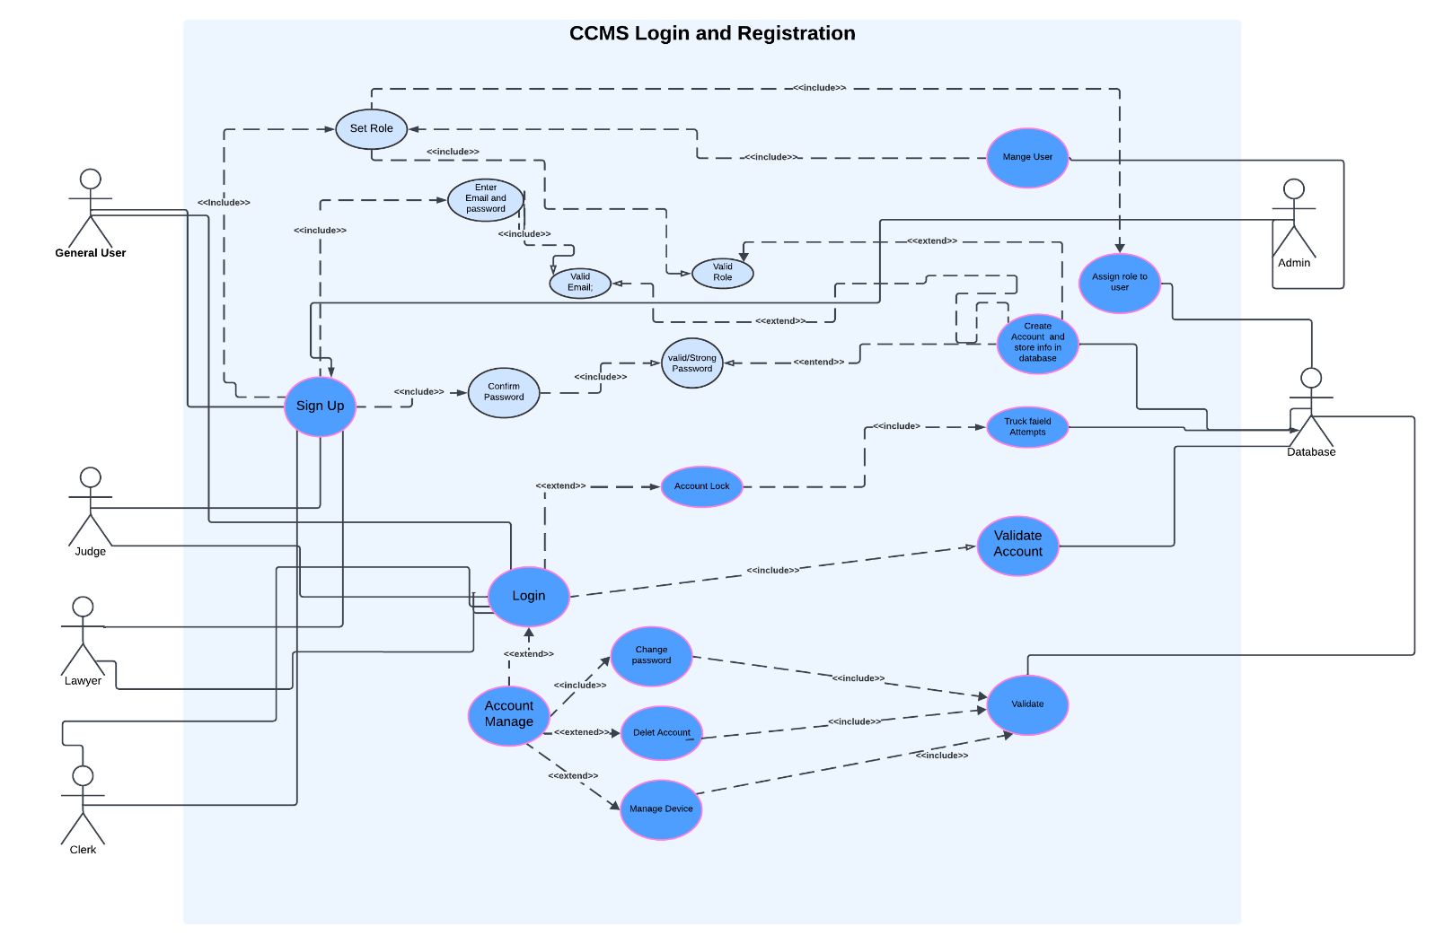

### ****Functional Requirements****

**User Registration**:

* 1. The system must allow users to create an account by entering an email, password, and confirming their password.
  2. Users must select and validate their role (e.g., Judge, Lawyer, Clerk).
  3. The system should validate the entered email and ensure the password is strong.

**User Login**:

* 1. Users must be able to log in using their registered credentials.
  2. Failed login attempts should be tracked, and accounts must be locked after a predefined number of failed attempts.

**Account Management**:

* 1. Users should be able to manage their accounts, including changing their password, deleting their account, and managing associated devices.

**Role Management**:

* 1. Administrators should be able to assign roles to users and manage user data.

**Validation**:

* 1. Accounts must be validated after registration before granting full access to the system.

**Audit and Monitoring**:

* 1. The system should keep track of failed login attempts for security purposes.

**Database Interaction**:

* 1. All account data (email, password, role) must be securely stored in a database.

### ****Non-Functional Requirements****

**Performance**:

* 1. The system should handle multiple simultaneous login and registration requests without performance degradation.

**Security**

* 1. All passwords must be encrypted before storage.
  2. The system must prevent unauthorized access by locking accounts after repeated failed attempts.
  3. Strong validation rules should be implemented for password creation.

**Usability**:

* 1. The registration and login process should be intuitive and user-friendly.

**Audit Trail**:

* 1. All critical actions (role assignment, account validation) should be logged for auditing purposes.

**User Story**

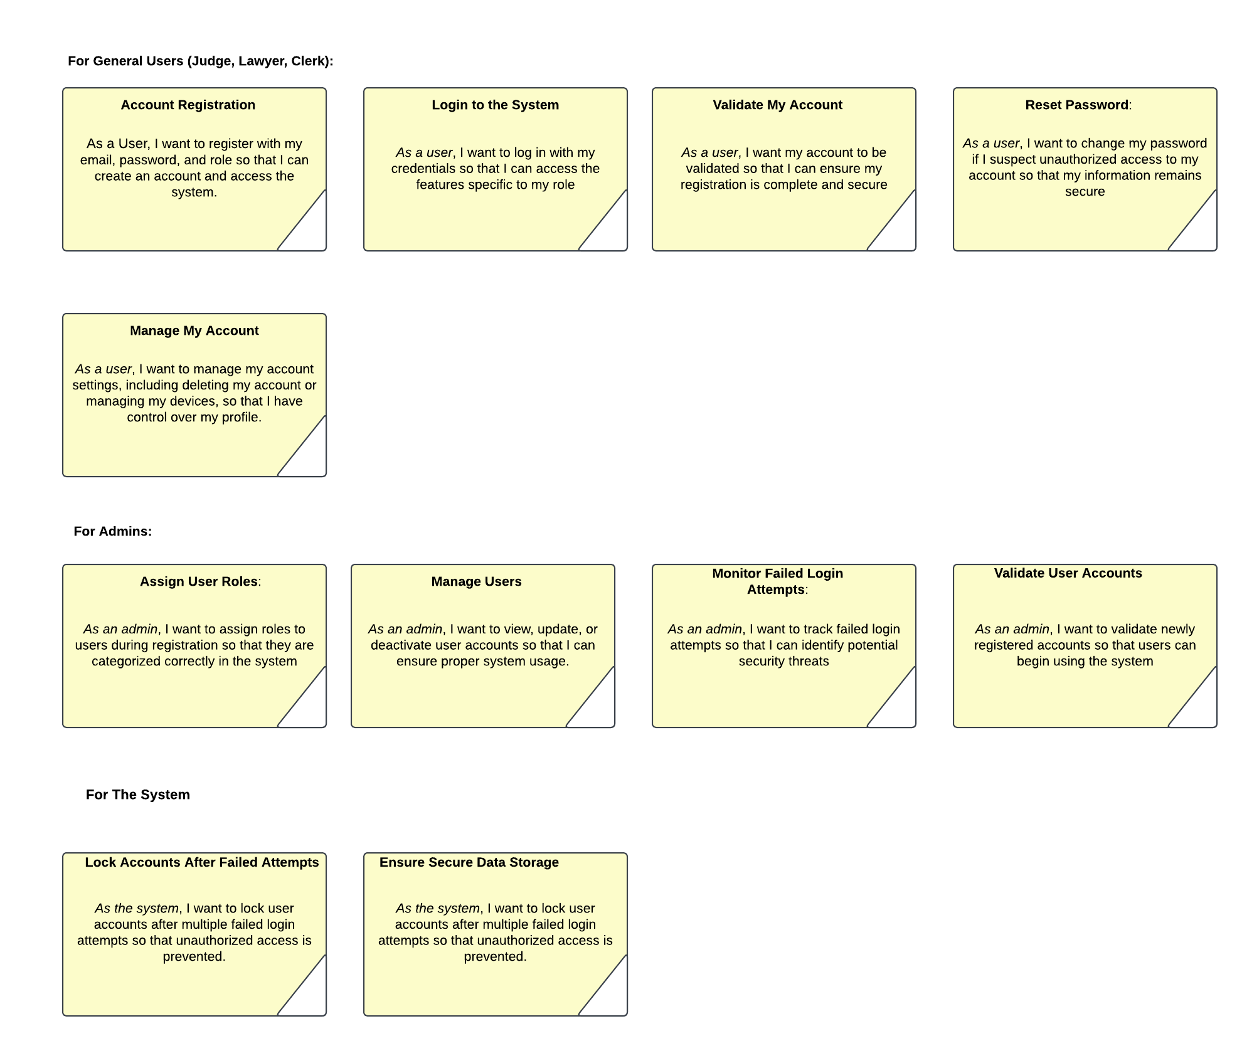

**Use Case Specification**

|  |
| --- |
| **Login and Registration**: Login and Registration |
| **Actors**: General User (Judge, Lawyer, Clerk) Admin System (as an automated actor), Database.  **Description:**  **Registration:**   1. **The user selects the "Sign Up" option.** 2. **The system prompts the user to enter an email, password, and confirm the password.** 3. **The system validates the email and password (e.g., password strength and format).** 4. **The user selects a role (e.g., Judge, Lawyer, Clerk)** 5. **The system validates the role and stores the account in the database.** 6. **Admin reviews and validates the account for activation.**   **Login**:   1. The user selects the "Login" option. 2. The system prompts the user to enter their email and password. 3. The system checks the credentials against the database. 4. If valid, the user is granted access to their role-specific dashboard**.** 5. If invalid, the system increments the failed attempt counter   **Account Management**:   1. The user selects "Manage Account." 2. Options are provided to:   · Change Password  · Delete Account  · Manage Devices   1. The system executes the requested action and updates the database.   **Exception:**   1. If the system is offline or database connection fails, an error message is displayed, and the operation is terminated. 2. Users can request a password reset link if they cannot remember their password.   **Preconditions**:   1. The system must be online and accessible. 2. A valid database connection must be established. 3. Users must provide unique and valid credentials during registration.   **Postconditions**:   1. Users are successfully registered and validated. 2. Users can log in and access role-specific features. 3. Failed login attempts are tracked, and accounts are locked after multiple failed attempts. |

**Class Diagram**

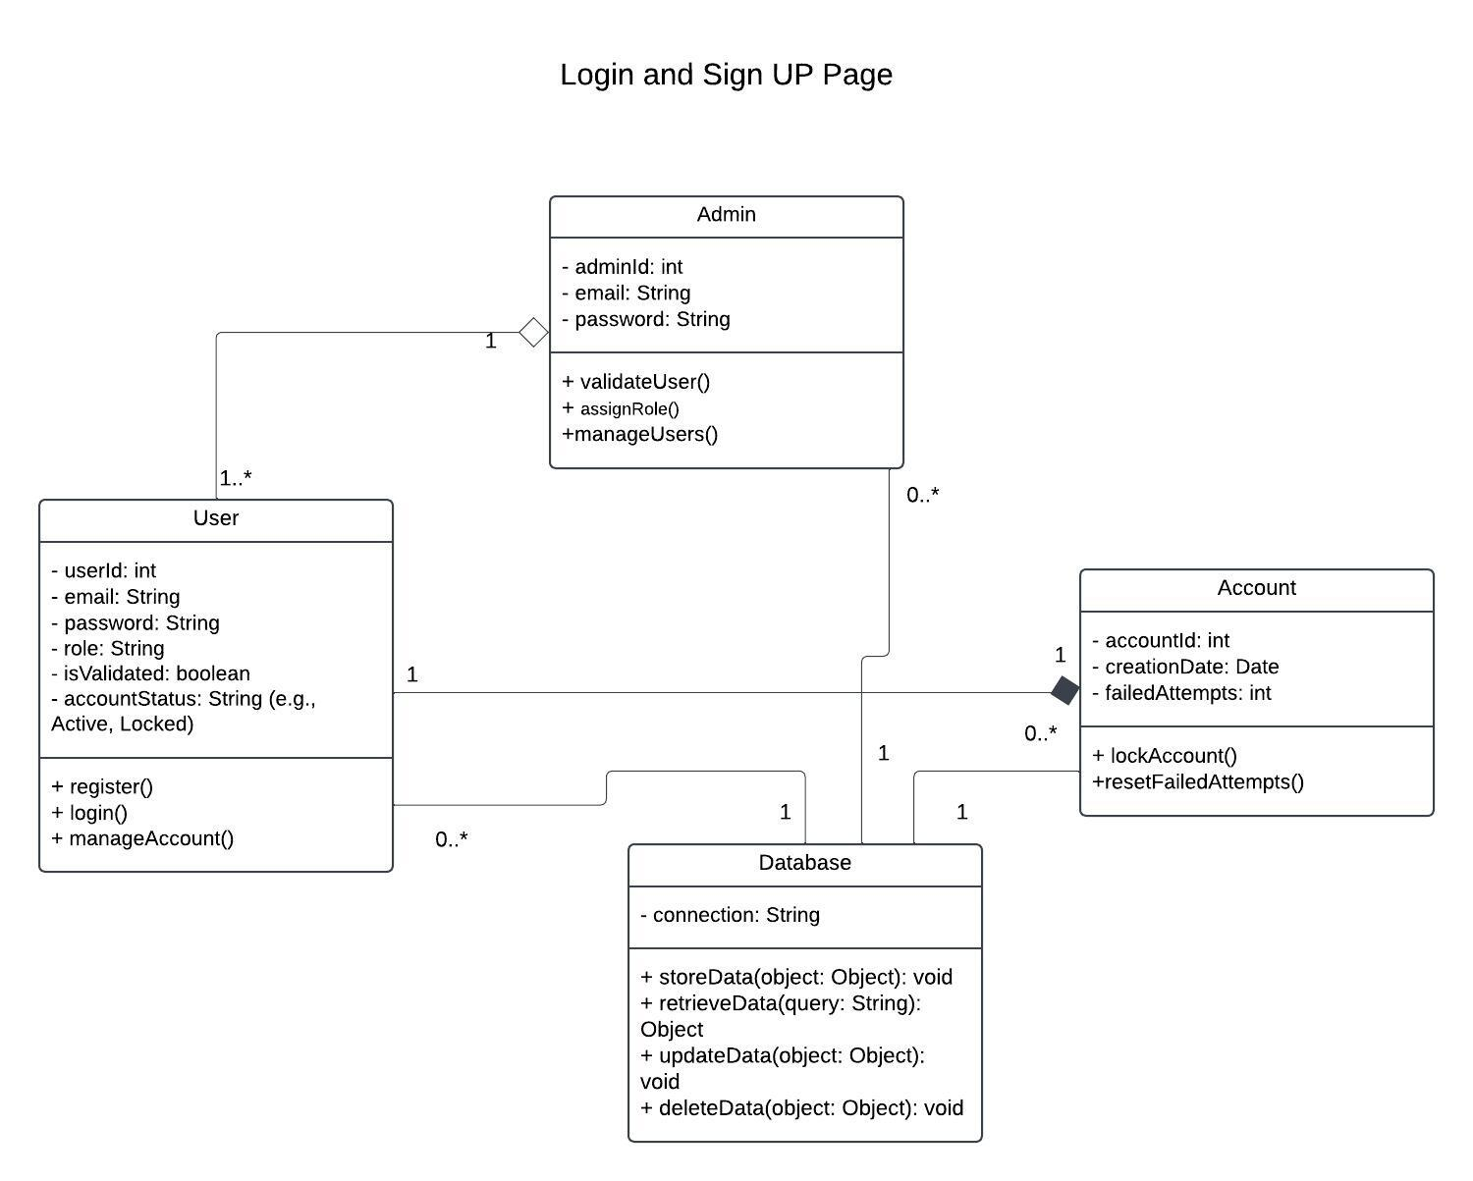

**Sequence Diagram**

